**CONTACT:**

PHONE: +91 90283 00351

EMAIL:

[halolisatish0351@gmail.com](mailto:halolisatish0351@gmail.com)

**ADDRESS:**

58 A Kanchan Ganga Nagar Jule Solapur, Solapur, 413004

**PERSONAL DATA**

Date of Birth: 06/01/1998

Sex: Male

Nationality: Indian

Marital Status: Single

Languages:

English, Hindi, Marathi, Kannada

HALOLI

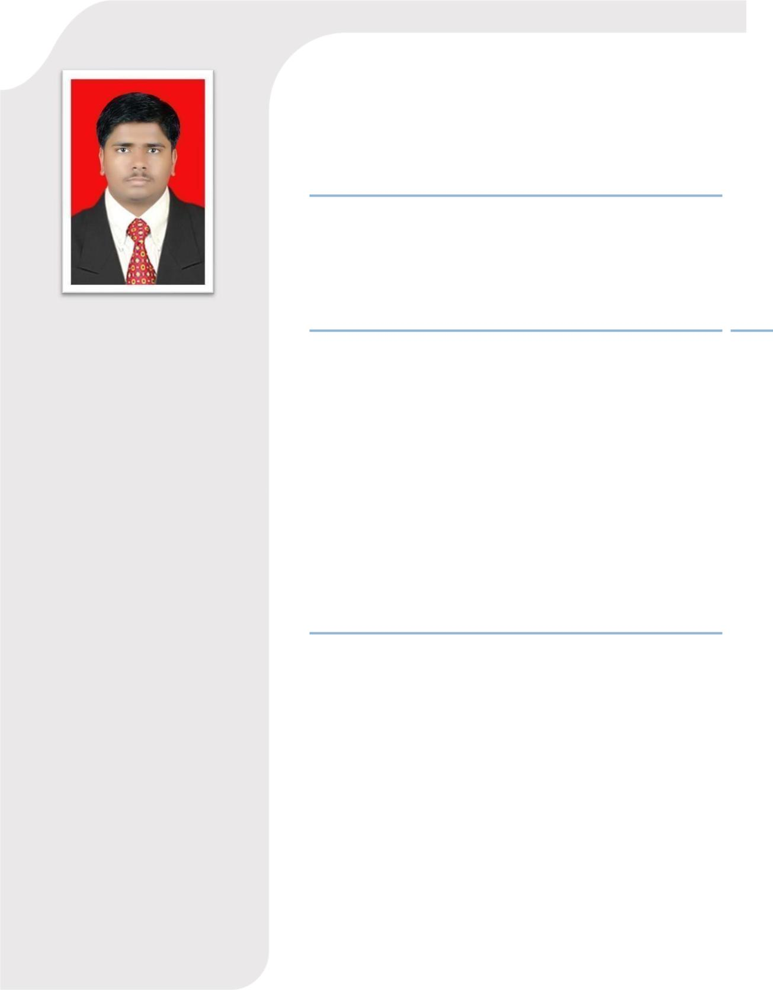

SATISH SAMBHANNA

[Mechanical Engineer]

**OBJECTIVE**

I seek a job as a mechanical engineer in a company where I can use my technical skill and knowledge which will ultimately in response to the visions of the company So as to meet the organizational goals.

**PROJECT**

1. Design and Manufacturing of Braking system in

ATV

* + Description: - Design, Analysis & Implementation of the Braking System for All Terrain Vehicle.
  + Responsibilities: - Worked as a Group co-leader for a group of 4 and contributed in the Braking System Design for the ATV

⦁

1. Participated in the Virtual BAJA SAEINDIA2018 organized by SAEINDIA

**EDUCATION**

N B Navale Sinhgad College of Engineering, Kegaon, Solapur. [Department of Mechanical Engineering]

|  |  |  |  |
| --- | --- | --- | --- |
| Exam | University | Year | % |
| B. E | Solapur | 2016-20 | 71 |
|  | University |  |  |
|  |  |  |  |
| HSC | State Board | 2015 - 16 | 64.46 |
|  |  |  |  |
| SSC | State Board | 2013 - 14 | 70.20 |

**SKILLS:**

* Quick Learner
* Positive Thinking
* Hard Worker
* Adaptability

**HOBBIES:**

* Watching movies, cricket.
* Travelling.
* Playing Cricket.

**ACHIEVEMENTS**



* Designed and implemented braking system of the ATV and participated in MEGA ATV championship 2019 which was held at GOA and 16th Rank in overall INDIA, Where I contributed as Braking system team co-head for ATV, we got participation certificate in SEA BAJA 2019.
* AIR-2 for the RCDC 2019 Competition (ATV)
* Attended the entrepreneurship awareness camp organized by MIT-TBI, Pune.

**TRAINING ATTENDED**

* Summer Training (2019) from Leena Engineering Works, Solapur.

**EXTRA CURRICULAM ACTIVITIES**

* Volunteer At ITRDC-2017 in Collaboration With BARC, Mumbai.
* Work for Social Welfare Under NSS Cell of Solapur university.

**WORK EXPERIENCE**

* **Job Title –** Production Engineer 
* **Name of company –** Chrysalis Castings Pvt. Ltd. Pune. 
* **Date of employment –** 01/02/2021 to till date 

**ROLE AND RESPONSIBILITY**

* Responsibility for all production related activity like achieving daily target,reduced rejection and lumps.
* To remove trouble shooting of process by optimizing the process and increase the productivity.



* To make standard parameters for machine operation and set machine under parameter.
* Check product quality as per customer require and defect free.
* Shift management and job distribution for entire manpower by utilizing all available.
* Fill up process parameters monitoring sheet and machine start-up check sheet.
* Successfully trial new setup and prepare their document.
* Productiion entry and reporting to production manager for any abnormality.
* Ensure maintain 5’S on shop floor and making kaizen for continuous improvement.

**REPORTING:-**

* I am reporting to shift Engineer.
* Daily maintain LOGBOOK and find Root Cause of machine and breakdown time.

**DECLARATION**

I hereby declare that the above-mentioned information is correct up to my knowledge and I bear the responsibility for the correctness of the above-mentioned particulars

Date: / /2022

Place: Solapur

Haloli Satish Sambhanna.